**AI Assignment 2A**

**Neeti Kurulkar**

**A* Search Algorithm**

**Code:**

**class Graph:**

**def __init__(self, adj_list, h_dist):**

**self.*adj_list* = adj_list**

**self.*h_dist* = h_dist**

**def find_neighbours(self, v):**

**"""Find the neighbours of a node"""**

**return self.*adj_list*.*get*(v, [])**

**def h(self, n):**

**"""Return the heuristic distance from current node to goal node"""**

**return self.*h_dist*[n]**

**def a_star(self, start, goal):**

**"""Return the path from start node to goal node (if exists)"""**

**open_set = set(start)**

**closed_set = set()**

**g, parents = {}, {}**

**g[start] = 0**

**parents[start] = start**

**while open_set:**

**print(f"\nOpen Set: {open_set}")**

**print(f"Closed Set: {closed_set}")**

**# Select node with the smallest f = g + h**

**current = min(open_set, key=lambda v: g[v] + self.*h*(v))**

**print(f"Processing Node: {current}, f = g + h = {g[current]} + {self.*h*(current)} = {g[current] + self.*h*(current)}")**

**if current == goal:**

**path = []**

**while parents[current] != current:**

**path.*append*(current)**

**current = parents[current]**

**path.*append*(start)**

**path.*reverse*()**

**print(f"\nPath Found: {path}")**

**return path**

**open_set.*remove*(current)**

**closed_set.*add*(current)**

**for neighbour, weight in self.*find_neighbours*(current):**

**if neighbour in closed_set:**

**continue**

**tentative_g = g[current] + weight**

**if neighbour not in open_set or tentative_g < g.*get*(neighbour, float('inf')):**

**parents[neighbour] = current**

**g[neighbour] = tentative_g**

**open_set.*add*(neighbour)**

**if open_set:**

**next_node = min(open_set, key=lambda v: g[v] + self.*h*(v))**

**print(f"Next Selected Node: {next_node}, f = g + h = {g[next_node]} + {self.*h*(next_node)} = {g[next_node] + self.*h*(next_node)}")**

**print("\nPath Does not exist!")**

**return None**

**# Adjacency list representation of the graph**

**adj_list = {**

**'S': [('A', 4), ('B', 3)],**

**'A': [('D', 6), ('C', 12)],**

**'B': [('C', 10), ('E', 7)],**

**'C': [('G', 5)],**

**'D': [('G', 16)],**

**'E': [('C', 2)],**

**'G': []**

**}**

**# Heuristic distances from each node to the goal**

**h_dist = {**

**'S': 14,**

**'A': 12,**

**'B': 11,**

**'C': 4,**

**'D': 11,**

**'E': 6,**

**'G': 0**

**}**

**# Create the graph and execute A* search**

**g = Graph(adj_list, h_dist)**

**g.*a_star*('S', 'G')**

**Output:**

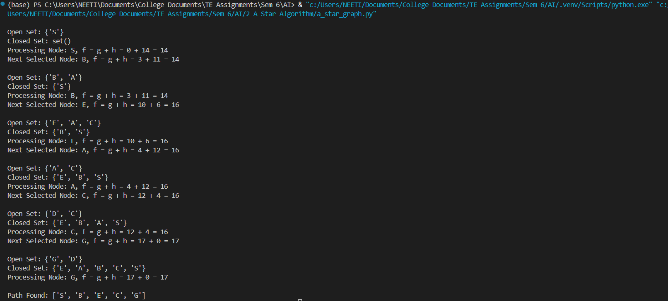

**‘A’ ---> ‘E’**

